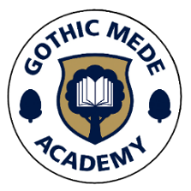

Newsletter No. 9
Pride in ourselves, pride in our school, pride in our community.
Friday 13th March

Dear Parents/ Carers,
What a week it has been! We have enjoyed having our parents in this week for breakfast to celebrate our wonderful Mums. The children enjoyed a bacon sandwich and an orange juice, along with other options, ensuring they were well fuelled for the day! A special thanks to our kitchen team and the staff who volunteered to help the event run smoothly.
Ash class were so impressive this week showing off their quick recall or FORTY words they had learnt to read. It was lovely to see how proud they were of themselves and how proud the staff were too!
Have a lovely weekend.
Mrs Smith

YEAR 4
Last week's World Book Day happily coincided with Rowan's class reward, a trip to the park. The children took the opportunity to 'Go All In' and read their favourite books in the sunshine.

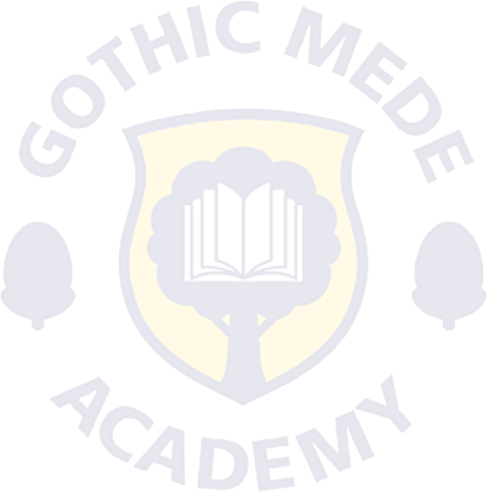
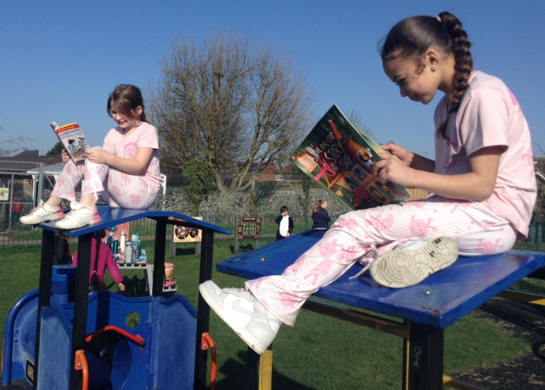

RED NOSE DAY – FRIDAY 20th MARCH
Next Friday we will be celebrating Red Nose Day at GMA. Children are invited to wear non-school uniform and include something red to show their support for Comic Relief.
A £1 donation will be available to pay via MCAS from Monday. Thank you in advance for helping us support this important charity.

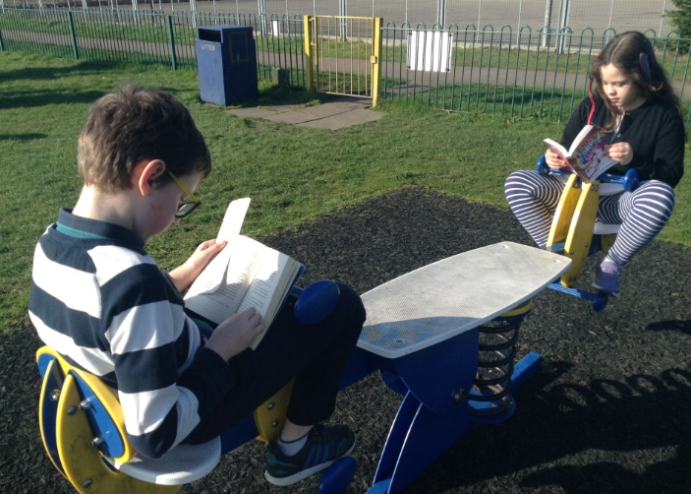

REQUESTS
We would be very grateful for any donations of children’s clothes hangers that you may have at home. We are also looking for junk modelling materials, such as cardboard boxes, plastic bottles, and similar recyclable items. Please ensure that nothing donated has previously contained nuts.
Thank you very much for your support!

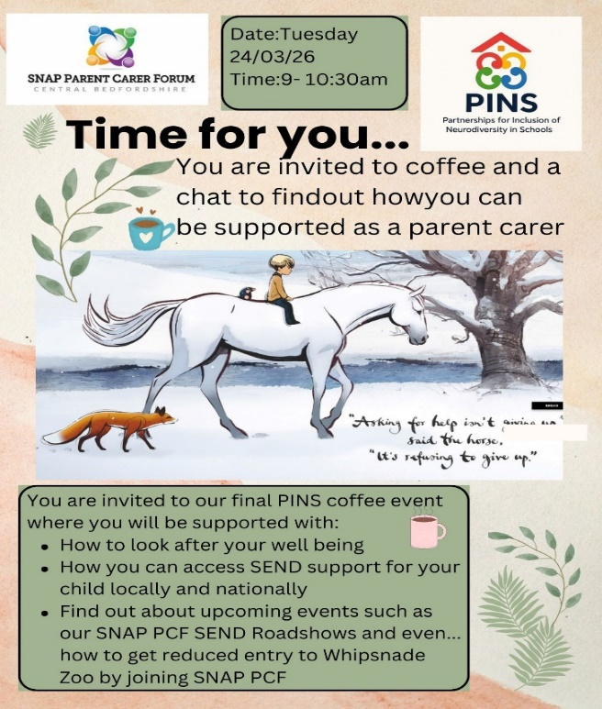
🔴 RED NOSE BAKE SALE 🔴
The kitchen team will be holding a Red Nose Bake Sale after school next Friday (20th). All items will be 50p each, with all profits going to Comic Relief.
If you would like to buy a treat, please try to bring the correct change where possible.
Thank you for your support!

SEN COFFEE MORNING
Come along to our SEN Coffee Morning on Tuesday 24th March, please use the link to inform us if you're able to attend.
We hope to see lots of you there!
https://forms.gle/eNh75JpKoyt74ys27

SCIENCE WEEK AT GMA

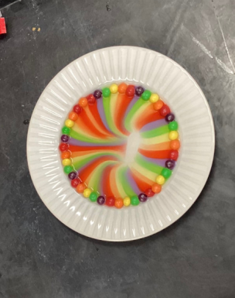
We have been very busy at Gothic Mede this week working scientifically to find out answers to our curiosities.

Acorn – “What happens when you mix hot and cold?”
We have been looking at how things change depending on other factors, we asked the children to predict what would happen. We did four different experiments, ice experiment where we added ice cubes to warm water, cold water and salt, chocolate experiment where we added chocolate buttons in a cup to a bowl of warm water and cold water, gingerbread man experiment where we put gingerbread men in a jug of warm water and cold water and skittles experiment where we add warm water and cold water to a plate of skittles.

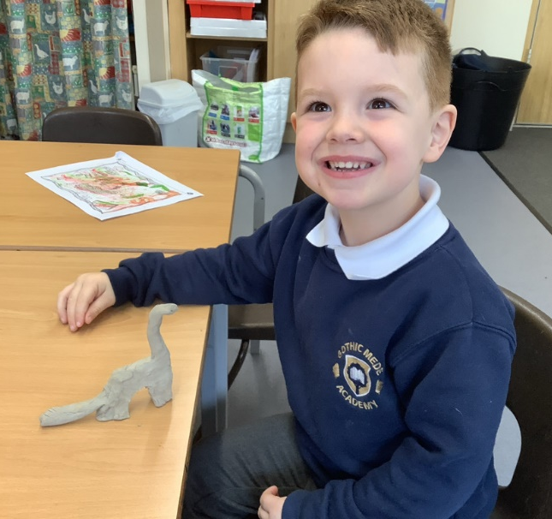
Reception - “Where did dinosaurs live?”
The children thought about how animals today have adapted to live in their habitats, discussing features such as fur or skin for camouflage, powerful hind legs to travel long distances, and fins to help animals swim.
They then applied this thinking to dinosaurs, discussing how different body features might give us clues about where dinosaurs lived and how they survived in their environments.
Finally, the children became young palaeontologists and created their own dinosaurs out of clay. They carefully thought about the habitat their dinosaur might live in and designed body features that would help it survive there.
It was wonderful to see the children asking thoughtful questions and using their scientific thinking and creativity throughout the week.

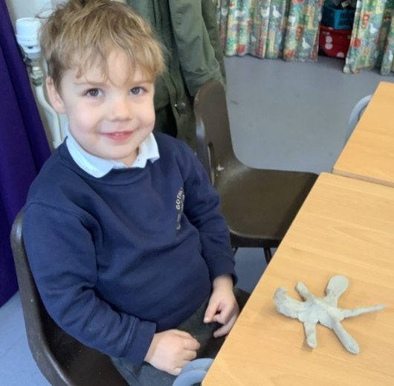
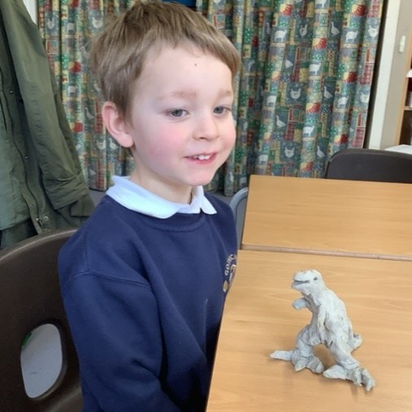
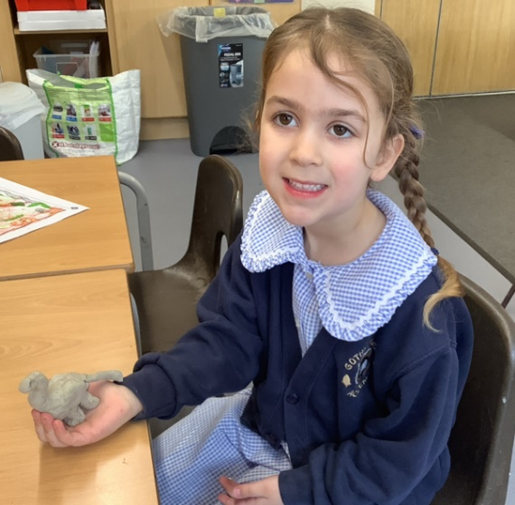

Year 1 – “How do animals survive?”
The children started their journey by looking at animal adaptations. They explored how different creatures have "special powers"—like thick fur for the cold or long necks for reaching high leaves—to help them survive in their unique habitats around the world. The highlight of the week was learning about animals that live closer to home. We explored what it takes to keep pets safe. A huge thank you to Orla from Acorn Class! She brought her pet hamster in to visit Year 1, giving the children a chance to see animal care in action. Year 1 have also been learning about the vital role vets play in animal survival. The children have been discussing how vets treat injuries and illnesses, thinking of brilliant questions to ask a professional and preparing for their upcoming visit from a training vet next week!

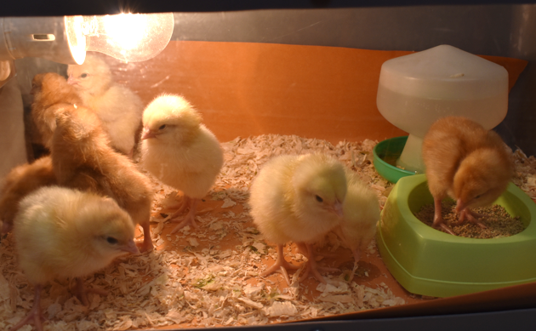
Year 2 – “What is a life cycle?”
The children were very excited to have living eggs in the classroom, and we were thrilled to watch them hatch into fluffy chicks!
The class has been full of curiosity, asking lots of thoughtful questions about how the chicks will grow and change. Over the next week, the children will be carefully observing and measuring the chicks, learning how scientists study living things and record changes over time. It has been a wonderful hands-on experience, helping the children see the life cycle in action and develop their scientific thinking.

Year 3 – “How are shadows formed?”
We have been investigating how shadows are formed and finding patterns in the way that the size of shadows change. The children started the week looking at how the light source from the sun creates shadows and how these shadows change throughout the day. We then experimented with torches finding out how to make shadows bigger and smaller by moving the object closer or further from the light source. We ended by creating our own shadow puppet shows which the children thoroughly enjoyed performing to each other.

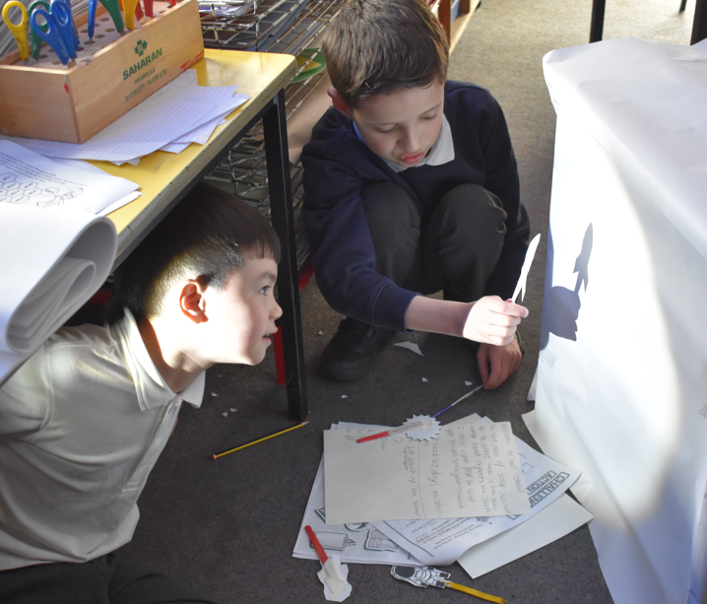
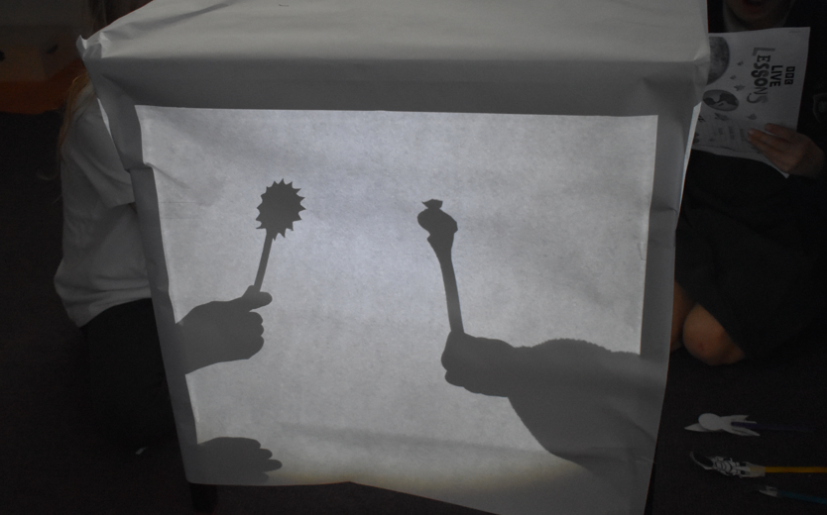

Year 4 – "Where does the water go?"
Year 4 investigated the water cycle. We went outside to make puddles, drew around them and measured them throughout the day. They evaporated over the day. Later in the week we created a 'water cycle' in a jam jar. We added hot water to the jar, which evaporated, and used ice cubes to cool the lid. This then made the evaporated water condense and cause 'rain.'

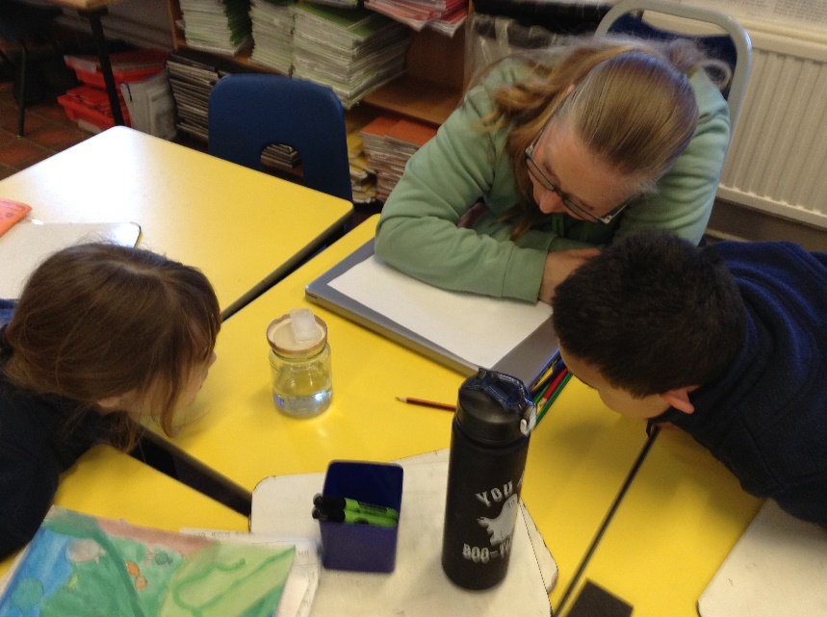
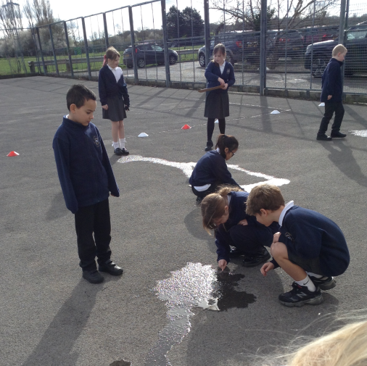


Golden Book

Children are nominated by Teaching Assistants and Teachers for a Principal’s award which is entered in the
Golden Book. The award can be for living one of our Values or special achievement. Sporting awards/achievements
gained through a regular commitment to a club or group are also celebrated.

Ash Abiya for taking responsibility for her learning by always being ‘ready’ to learn and for the fantastic effort she is putting into her writing.

Oak Rohan for his excellent engagement in phonics sessions and the brilliant effort he is putting into his writing.

Beech Ryo for taking such care with his handwriting and use of full stops and capital letters when creating a fact file.

Elm Romearo for showing great engagement during maths. This week Romearo has worked hard to partition numbers into tens and ones.

Willow Harrison for his contributions to lessons, particularly his imaginative ideas for descriptive writing in English.

Maple Anmoldeep for always using good manners and being respectful when speaking.

Chestnut Karina for her excellent effort to take pride in her written work in English ensuring that her handwriting is joined and neatly formed.

Sycamore Nevaeh-Mae for making great progress with her maths fluency. Nevaeh is working hard to master her square times table.

Rowan Pixie-Lilly for her excellent engagement with and participation in our assembly practice.



CELEBRATIONS
- Ato (Chestnut) was awarded a football trophy for scoring a hattrick at the tournament he played in this weekend, Ato plays for Stotfold Reds U8s.
- Cillian (Sycamore) was awarded a certificate and green stripe belt in taekwondo.
- Lily (Willow) was awarded a certificate for taking part in the Arlesey library World Book Day search.

UPCOMING EVENTS
Wed 18th March | Reception Phonics Workshop
Thurs 19th March | Year 4 Assembly – Parents welcome
Thurs 19th March | Acorn Toothbrushing Visitor
FROM THE KITCHEN
Please can we remind parents, when purchasing school dinners, this must be done 2 days in advance. Please also choose the days your child wants dinner on, we don't always have spare, we cook to the numbers we have. Thank you.

https://www.gothicmede.org.uk/schoolmeals

Web Site: www.gothicmede.org.uk Email: GMA-Office@bestacademies.org.uk

Facebook: @gothicmede Phone: 01462 732002

Web Site: www.gothicmede.org.uk Email: GMA-Office@bestacademies.org.uk

Facebook: @gothicmede Phone: 01462 732002

