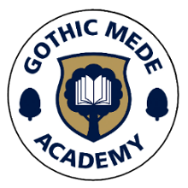

Newsletter No. 8
Pride in ourselves, pride in our school, pride in our community.
Friday 6th March

WORLD BOOK DAY
We have had a fantastic day celebrating World Book Day at Gothic Mede! The children enjoyed a range of fun activities throughout the day, all inspired by a love of reading. The children looked amazing in their costumes and pyjamas, and the staff also made a brilliant effort to join in the fun.
Our kitchen team prepared a wonderful book-themed lunch, inspired by some classic stories, which the children thoroughly enjoyed. During the day, pupils took part in activities such as designing their own book tokens, completing a reading quiz, and voting for which staff member’s favourite book they would like to hear being read aloud. We hope the children enjoy exchanging their book tokens at local bookshops. You can find out more about the books here: https://www.worldbookday.com/books-and-tokens/
Don't forget, Arlesey library (Resource centre) is open after school on Tuesday and Thursday afternoons and on Saturday mornings, so why not pop in with your child to discover where their reading vibe takes them.
It was a lovely day celebrating books, stories and the joy of reading!

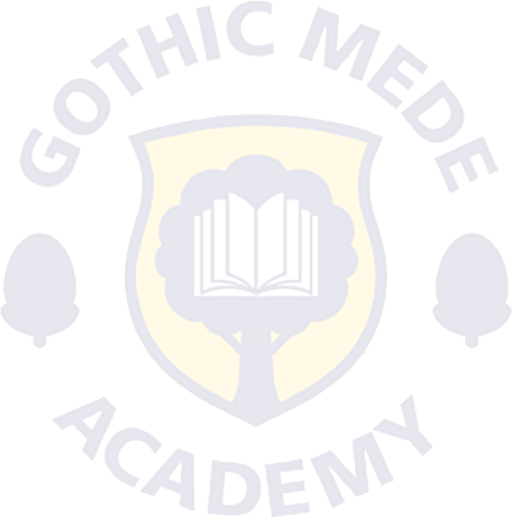

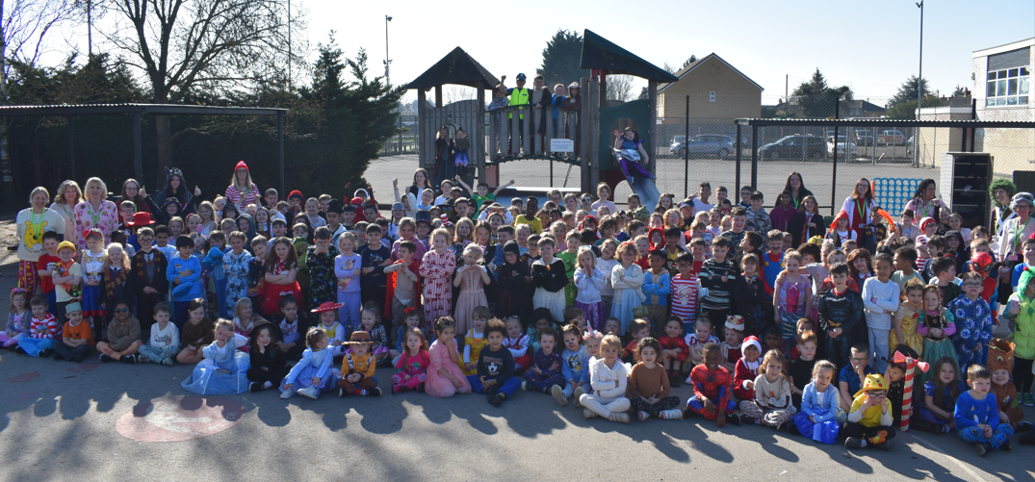

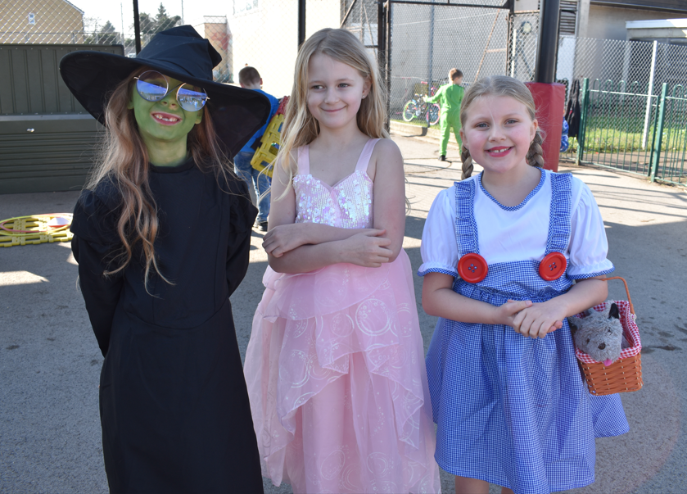
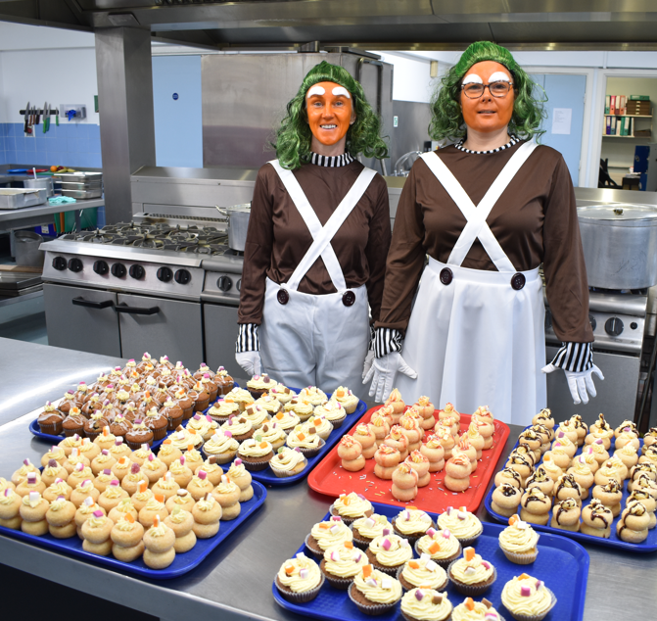

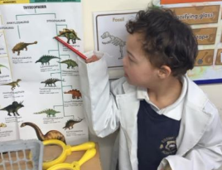
RECEPTION
Last week, the children in Reception began their exciting new topic all about dinosaurs. They have been very enthusiastic and curious, and have loved immersing themselves in their learning.
The children have enjoyed exploring the Palaeontologists’ Lab, using magnifying glasses to closely examine fossils and draw what they can see. They have also been looking carefully at pictures of dinosaurs and discussing their different features.
It has been wonderful to see the children so engaged and excited about this fascinating topic!

STAFF INTERVIEW – Time for another Staff Interview and this week it’s Mrs Howard!
Name: Mrs Howard
Job title: Year 2 teacher and PE lead
How long have you worked at GMA? 16 years
What do you love about working at GMA? Working with the most amazing children!
What’s the best thing about your job? Helping children and getting to watch them learn and grow.
What do you enjoy doing outside of work? Walking up mountains and reading!
Favourite Book? Harry Potter
Favourite Sport? Running
Favourite Film? Willy Wonka



Thank you to Mrs Howard for taking part in our staff interview. It was lovely to learn more about her and the work she does in school. Keep an eye out for our next staff interview, coming soon!

Golden Ticket Fundraiser
THANK YOU!
We would like to say a huge thank you to everyone who purchased a Golden Ticket chocolate bar. Thanks to your incredible support, we raised approximately £700, which is fantastic! A special thank you goes to the PFGM for organising the event and making it such a success. We are very grateful to our parents and families for supporting these events and helping us raise valuable funds for the school. The money raised will go towards improving our playground, which will benefit all of our children. Thank you again for your continued support!

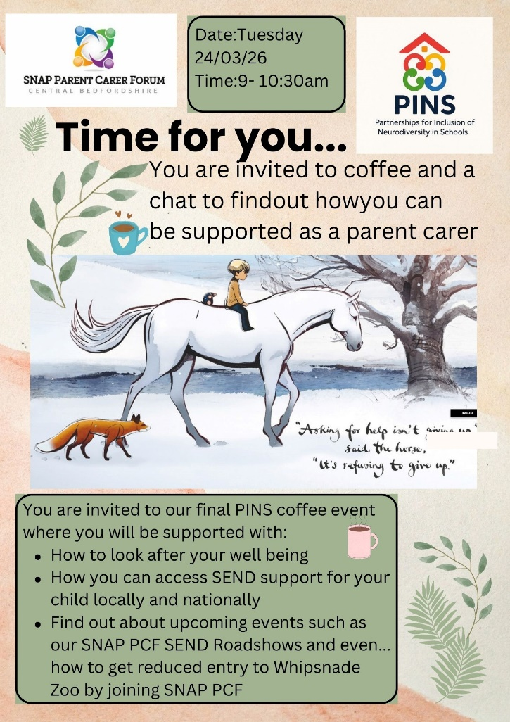

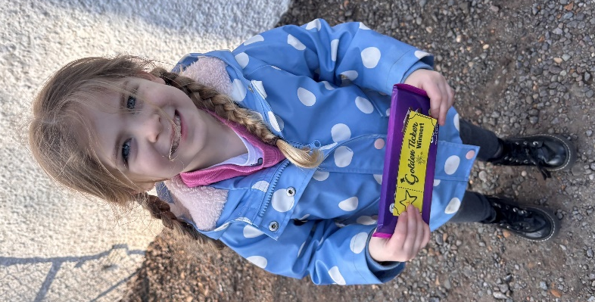

SEN COFFEE MORNING
Come along to our SEN Coffee Morning on Tuesday 24th March, please use the link to inform us if you're able to attend. We hope to see lots of you there!
https://forms.gle/eNh75JpKoyt74ys27


Golden Book

Children are nominated by Teaching Assistants and Teachers for a Principal’s award which is entered in the
Golden Book. The award can be for living one of our Values or special achievement. Sporting awards/achievements
gained through a regular commitment to a club or group are also celebrated.

Ash Isabella for having such a positive attitude towards all aspects of school and trying extremely hard, particularly with her writing this week.

Oak Ana for always being so enthusiastic towards every aspect of learning and putting so much effort into everything she does.

Beech Taylor for her fantastic effort in all lessons this week and for showing respect towards her peers and adults.

Elm Millie for showing curiosity in our new DT topic about building stable structures. Millie gave some great suggestions on how to make a building stable.

Willow Phoebe for her brilliant effort in Maths last week, Phoebe worked hard to share her answers with the class and complete her work independently.

Maple Charlie for settling into a new school and class really well and making new friends.

Chestnut Layla for her excellent effort and creative ideas in our English writing task to write a letter.

Sycamore Reggie for his engaging style when writing his instructional text "How to be a Fit Kid". Reggie really considered how to draw the reader into the text and worked hard to use cursive writing throughout.

Rowan Freddie, for the thoughtful and supportive manner in which he helped his classmate in mathematics. Unprompted, he explained to his friend how to work out mixed numbers in fraction work.



CELEBRATIONS
- Mila (Beech) received her red and black belt at martial arts.
- Ellie (Elm) awarded 2 swimming certificates for 5 metres distance and completing level 2

UPCOMING EVENTS

9th – 13th March | Science Week
Tues 10th March | Mother’s Day Breakfast
Wed 18th March | Reception Phonics Workshop
FROM THE KITCHEN
Parents of year 3 & 4 children
Please can you make sure your dinners options for next week are chosen by Sunday, either packed lunch or school dinners. This gives our Kitchen Managers the correct figures.
Thank you.
https://www.gothicmede.org.uk/schoolmeals

Web Site: www.gothicmede.org.uk Email: GMA-Office@bestacademies.org.uk

Facebook: @gothicmede Phone: 01462 732002

Web Site: www.gothicmede.org.uk Email: GMA-Office@bestacademies.org.uk

Facebook: @gothicmede Phone: 01462 732002

