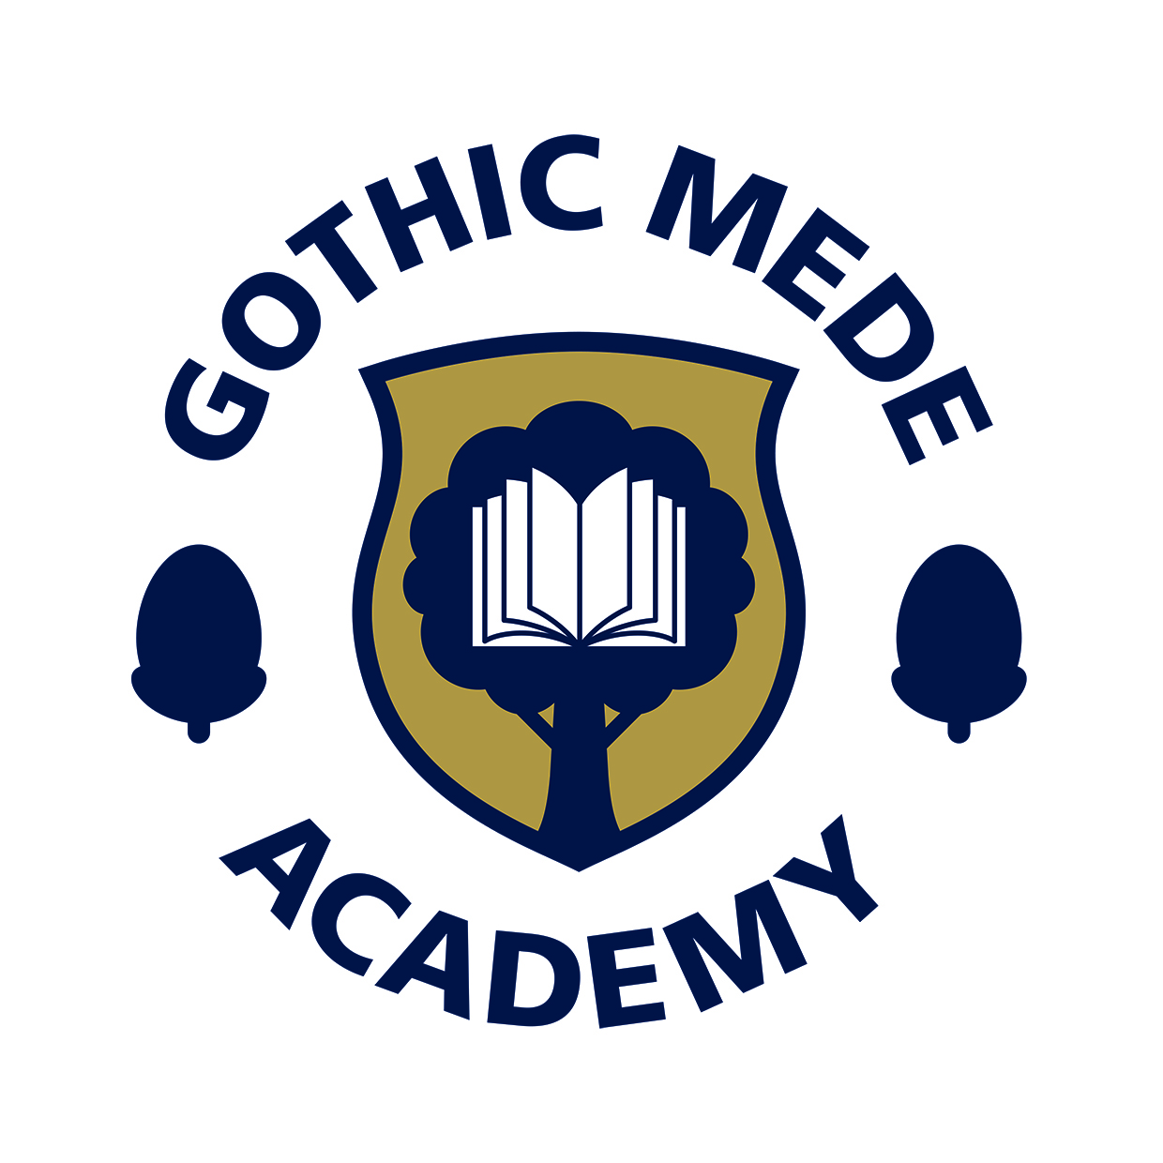
GOTHIC MEDE ACADEMY
SEND INFORMATION REPORT

What types of SEN do we provide for? | At Gothic Mede, we believe that every pupil, regardless of gender, race or disability, has a right to equal access to a broad and balanced curriculum.  We consider it essential that the curriculum is presented in a supportive and stimulating atmosphere, which values each child and encourages them to achieve their full potential.  This encompasses the four main areas of SEND.  - Communication and interaction  - Cognition and learning  - Social, mental and emotional health  - Sensory and/or physical
How do we identify and assess pupils with SEN? | Pupils will be identified through ongoing assessments by the child’s teacher, and brought to the attention of the SENCo if they are making less than expected progress, in spite of high quality, differentiated classroom teaching targeted at the child’s area of weakness.  Limited progress and low attainment do not necessarily mean that a child has SEN and should not automatically lead to a pupil being recorded as having SEN.  The SENCo will then work with other staff to investigate this further and may engage the help of external agencies in order to identify the area of need.
Who is our special educational needs co-ordinator (SENCO) and how can he/she be contacted? | Our school’s SENCo is Alison Sugden. She can be contacted through the normal channels of communication:  01462 732002  GMA –Office@bestacademies.org.uk
What is our approach to teaching pupils with SEN? | Special educational provision is educational provision that is additional to or different from that made generally for other children of the same age.  Teachers are responsible and accountable for the progress and development of the pupils in their class, including where pupils access support from teaching assistants or specialist staff.  High quality teaching, differentiated for individual pupils, is the first step in responding to pupils who have or may have SEND.  Gothic Mede Academy will take a graduated approach to supporting children with SEND and this is very specifically defined by the local authority’s two documents applicable to our age range:  - Guidance on SEND in the early years - a graduated approach 2018.  - Guidance on SEND age 5 – 16 – a graduated approach 2018.  Both of these documents can be found on Central Bedfordshire’s website under the local offer under ‘if your child has SEND’.  http://www.centralbedfordshire.gov.uk/children/sen-disability/landing.aspx  The special educational provision in place should follow the four part cycle:  - Assess. This could involve a range of methods including, but not limited to, teachers’ assessment of pupil progress, attainment and behaviour, results of standardised tests screening and profiling tests, questionnaires of parents and children and observations.  - Plan. This is likely to involve the SENCo, working with teachers to plan appropriate provision, which is clearly communicated with all concerned. This may be in class support or more targeted provision. Any planning will have a clear focus on expected outcomes for the child or young person.  - Do. The SEND Code of Practice places the teacher at the centre of the day-to-day responsibility for working with all pupils, it is imperative that teachers work closely with any teaching assistants or specialist staff involved to plan and assess the impact of targeted interventions.  - Review. The progress of pupils who are receiving SEN Support should be reviewed termly and teachers should meet with parents three times a year. This may form part of Gothic Mede Academy’s regular tracking processes.
How do we adapt the curriculum and learning environment? | At Gothic Mede Academy we will adapt the curriculum and learning environment so that all children can take their next steps in learning. This will include, for some children with SEND, broken down objectives from the national curriculum so that progress can be made and measured in the small steps that the children are able to take. It could include a completely individualised curriculum and, if necessary, timetable. This will be upon the guidance of external agencies to ensure that we best provide for each child’s needs.
How do we enable pupils with SEN to engage in activities with other pupils who do not have SEN? | It is our expectation that children with SEND will take part in all of the activities that are available at Gothic Mede. Sometimes children will be unable to do so in exactly the same way so we will find a way to adapt the activity to ensure that they are still able to take part. For example, simplifying the activity, providing adult or resource support for the child to complete the same activity, or allowing the children to take part in the activity with different expectations of the outcome. We encourage all at Gothic Mede to approach life with a Growth Mindset and this will support all pupils, including those with SEND, to choose to tackle activities at a level that challenges them.
How do we consult parents of pupils with SEN and involve them in their child’s education? | We endeavour to involve parents of pupils with SEND at each stage of the Assess, Plan, Do and Review process. Our initial contact with parents will be when teachers or parents identify an additional need in a child which is presenting as a barrier to learning. From this point we will discuss with parents strategies that all stakeholders find effective when supporting the child, we will create a plan to support the child, all parties will be part of supporting the child.
How do we consult pupils with SEN and involve them in their education? | All children at Gothic Mede Academy are expected to talk about their learning to each other and to adults. Part of this is to discuss their strengths and areas from development and subsequently, we encourage pupils with SEND to take part in identifying their strengths, needs and areas for development when creating support plans.
How do we assess and review pupils’ progress towards their outcomes? | Pupils’ progress is assessed against the expectations of the National Curriculum (2014) for each year group. In addition, they will be subject to statutory testing at different points of their time with us. Some children will not reach National Curriculum standards and these children will either be assessed against the P Levels or against small steps towards Year 1 curriculum objectives. These will be discussed with parents.
How do we support pupils moving between different phases of education? | The SENCo will support pupils moving into and out of the school by liaising with the SENCo of the previous or next school and sharing any plans and strategies that have been used at the child’s previous setting.
How do we support pupils preparing for adulthood? | Pupils who experience greater needs in accessing the curriculum will be monitored and planned for using a SEND Support Plan. This includes children and parents’ desired outcomes for the short and longer term.
What expertise and training do our staff have to support pupils with SEN? | All staff receive regular training to support pupils with high incidence SEND. In addition to this, staff who work with pupils who have specific learning difficulties and needs receive tailored training from external advisors such as advisory teachers, educational psychologists and the school nurse. These professionals are engaged as soon as school staff, in agreement with parents, decide that more specific advice is required to enable the pupil to progress. These professionals can also give advice for equipment and facilities that can be used to support pupils more effectively.
How do we evaluate the effectiveness of our SEN provision? | As with all practice at the school, staff evaluate the impact of the provision we make for pupils with SEND with regular monitoring including the use of assessments. These are used for all areas of additional need pupils may have.
How do we handle complaints from parents of children with SEN about provision made at the school? | Parents are able to contact the Principal if they have complaints about the provision made for their children with SEND at the school. If this is inappropriate, parents can contact the chair of governors through the contact details on our website – www.gothicmede.org.uk
What support services are available to parents? | Parents can access support from class teachers, the SENDCo and the Principal at Gothic Mede. Also available is support given by the Special educational needs and disability (SEND) parent, children and young person partnership service of Central Bedfordshire Council. They can be contacted at: http://www.centralbedfordshire.gov.uk/children/sen-disability/send-partnership/overview.aspx
Where can the LA’s local offer be found? | The local authority’s local offer can be found at:  http://www.centralbedfordshire.gov.uk/children/sen-disability/landing.aspx
How the school is improving accessibility.  Where can the academy’s Accessibility Plan be found? | Details of how the school is improving accessibility can be found in our Accessibility plan which can be found on our website on our Policies page: http://www.gothicmede.org.uk/Parents/Policies/ Please also see the equality policy.  Increasing curriculum participation  Staff are trained in how to support pupils with high incidence SEND.  A bespoke curriculum for some children with SEND to support progress in all areas of the curriculum.  Developing use of assistive technology e.g. Chromebooks  Improving the physical environment  The school has purchased a hoist and shower trolley and staff have been trained in moving and handling so that all equipment can be used safely.  The school works closely with the Local Authority Hearing Impairments and Visual Impairment services to improve accessibility of information to those students who need that level of support.  The school works closely with Occupational Therapist and Physiotherapists to gain advice and guidance on any necessary adjustments.  The school works closely with Ivel Valley to gain advice on adaptations needed for children with physical disabilities.

