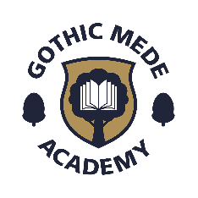
Local Governing Body - Gothic Mede Academy
Academic Year 2022-2023

Forename | Surname | Position | Date Appointed | Term of office | Date Term of Office Due to End /  Resigned | Attendance at Board meetings | Nature of interest | Name of organisation/person | Date interest registered | Date interest ceased
Thomas | Clarke | Principal | Ex Officio | N/A | N/A | 1 of 1 | Employment
Amy | Morris | Vice Chair (appointed 23/04/22)/Co-Opted | 27.03.2022 | 3 years | 27.03.2025 | 1 of 1 | Employment | BEST
Nicola | Davies | Co-Opted | 12.12.2021 | 3 years | 12.12.2024 | 1 of 1 | Employment | BEST
Mark | Greaney | Chair (appointed 23/04/22)/Co-Opted | 01.05.2021 | 3 years | 01.05.2024 | 1 of 1 | None - October 2022
Trudie | Squires | Co-Opted | 06.10.2021 | 3 years | 05.10.2024 | 1 of 1 | None - October 2022
Michael | Warlow | Staff | 29.01.2020 | 3 years | 28.01.2023 | 1 of 1 | Employment | BEST
Geraldine | Warren | Parent | 06.10.2021 | 3 years | 05.10.2024 | 1 of 1 | None - October 2022

As of October 2022

